**EXPERIMENT 9**

**Create a Snapshot of a VM and Test it by loading the Previous Version/Cloned VM**

Step 1: Create a new virtual Machine

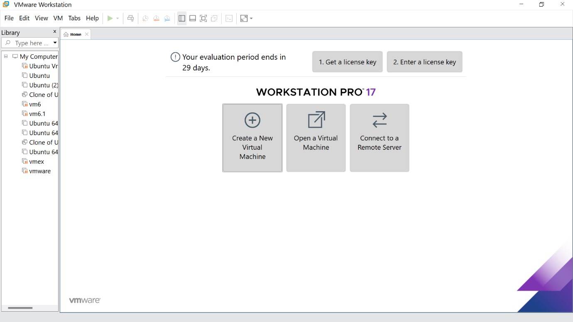

Step 2: Click the Typical option and click Next

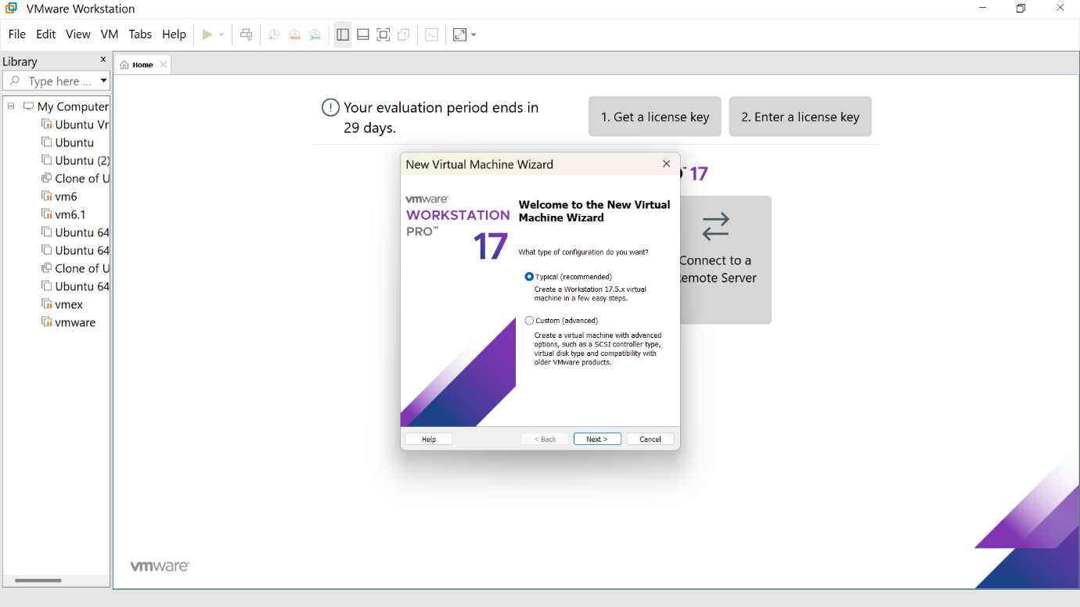

Step 3:Click the install option and proceed to the next step

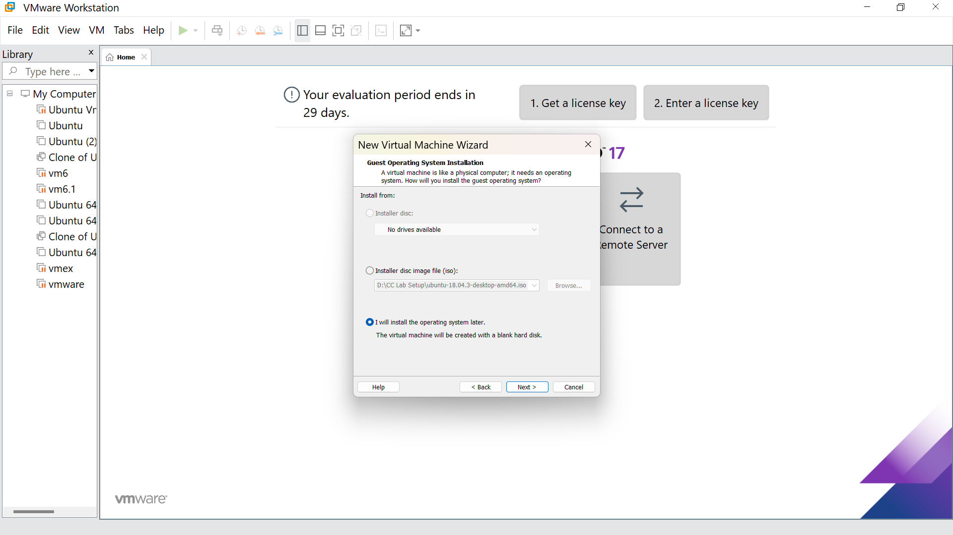

Step 4: Select the Linux option and click Next

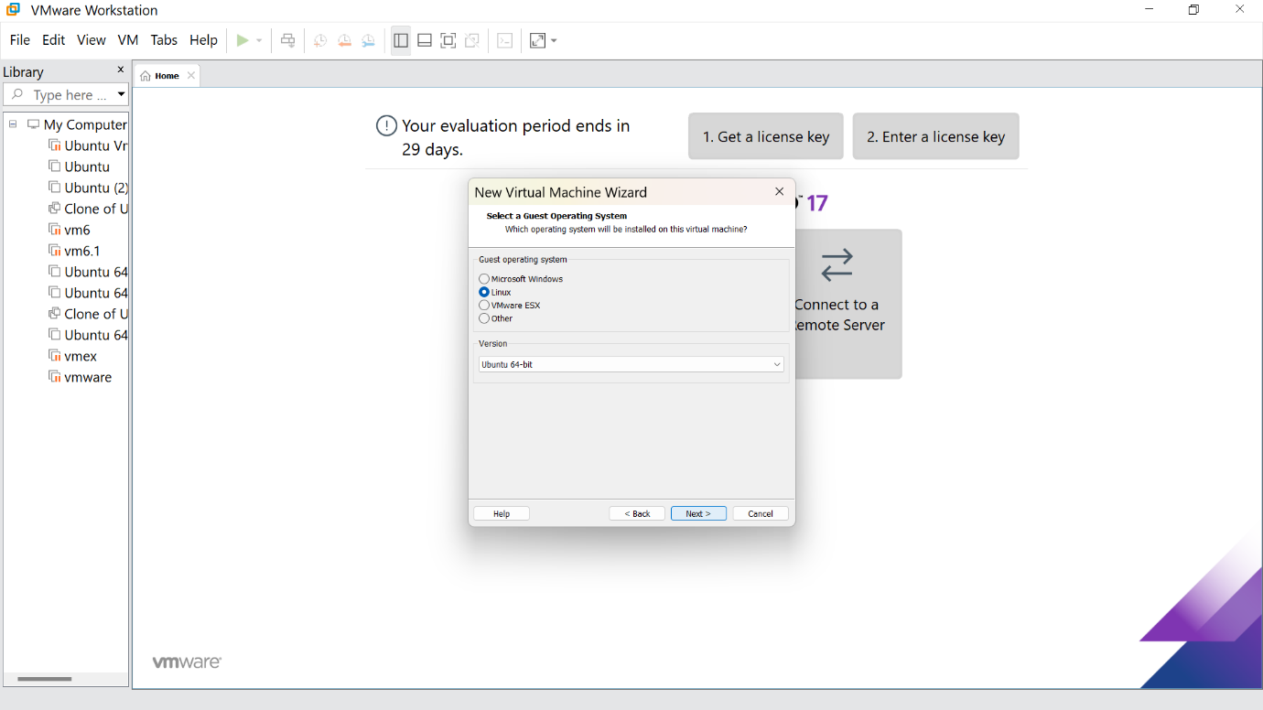

Step 5: Give the name for the virtual machine(optional) and click next

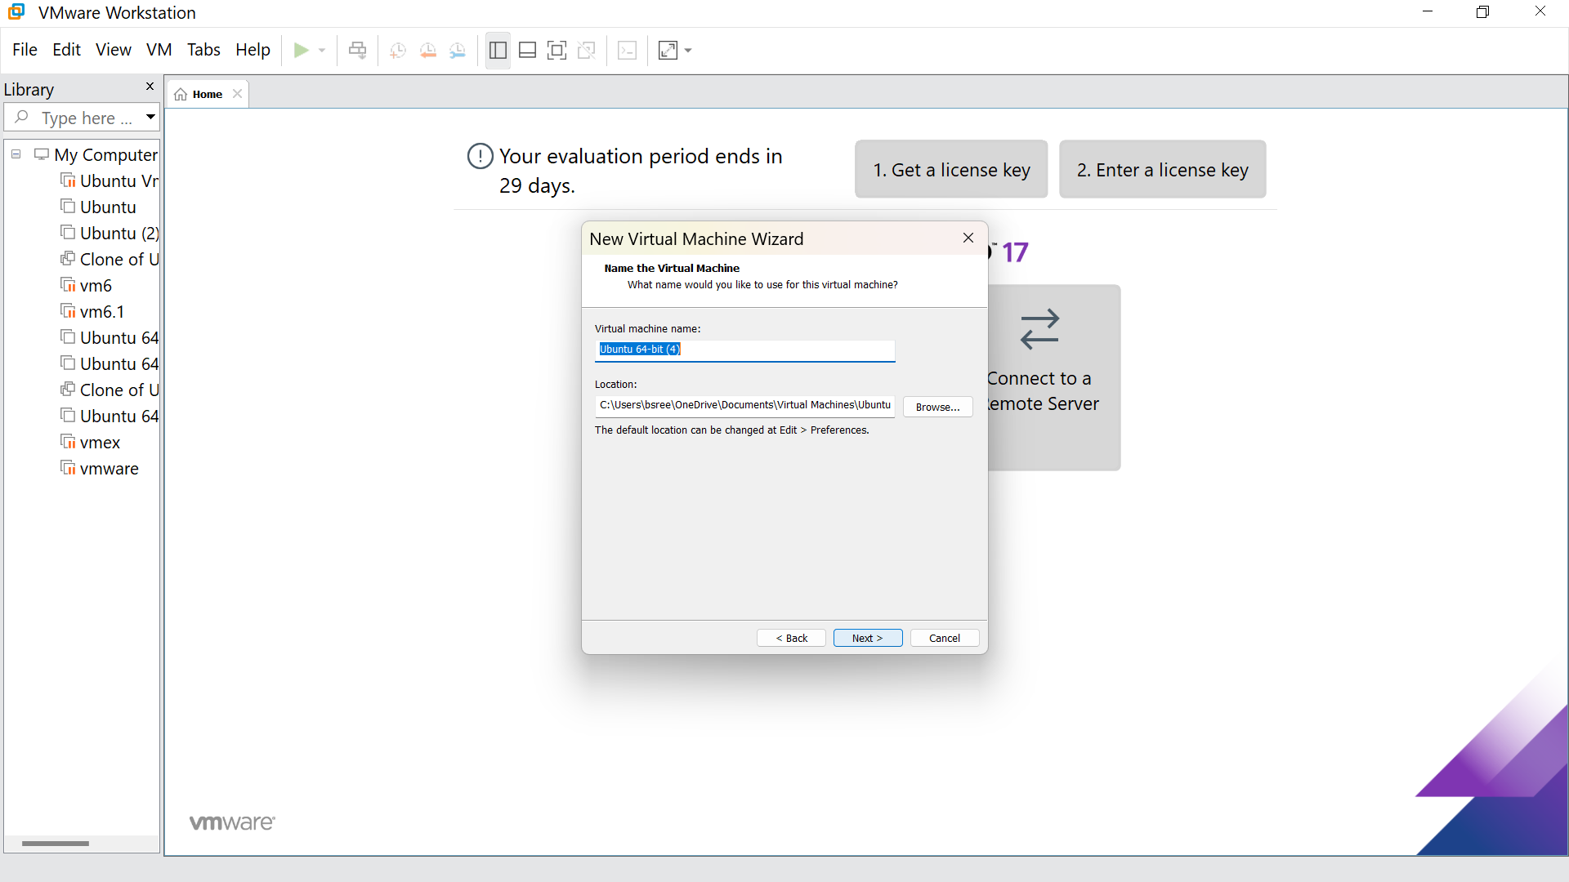

Step 6: Select the option to store the disk in a single file and click next

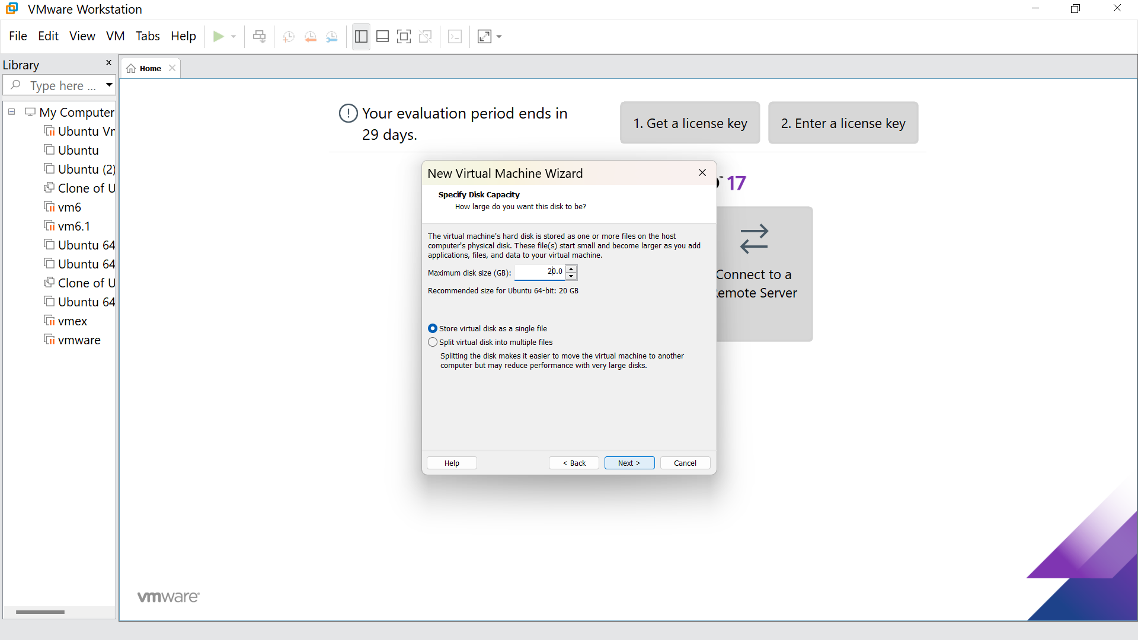

Step7:Our new VM is ready, click Finish

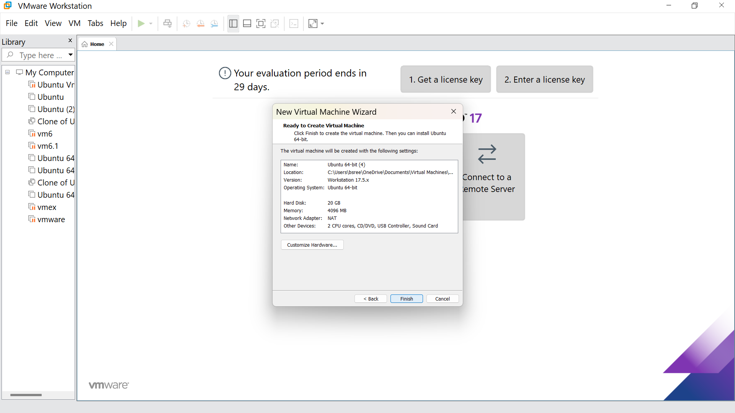

Step 8: This is the creation of a VM

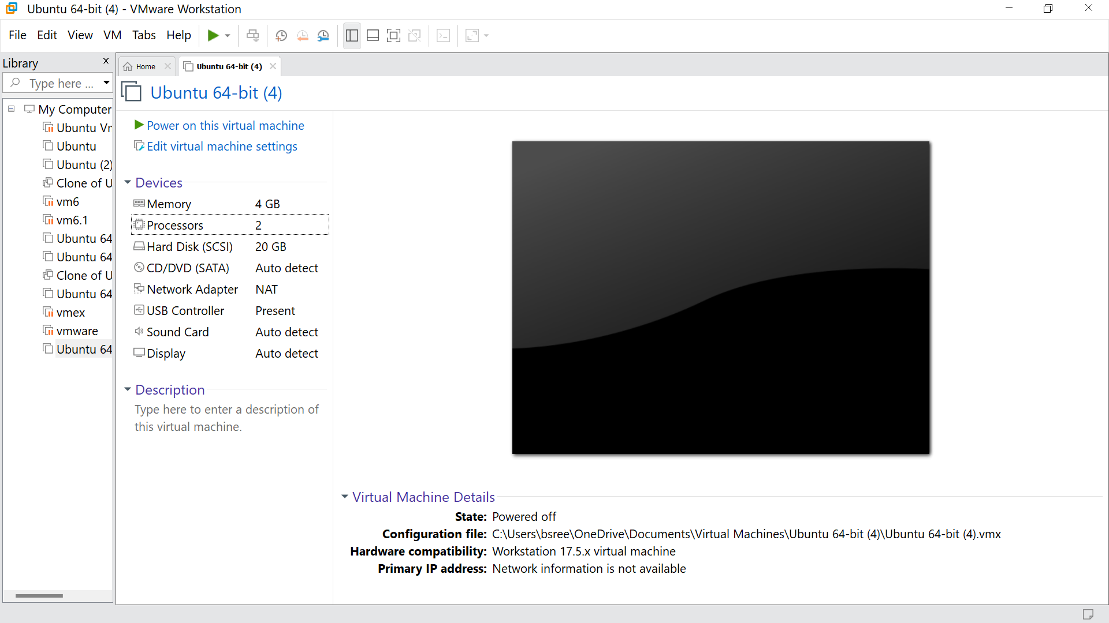

Step9: Go to the VM option and click manage

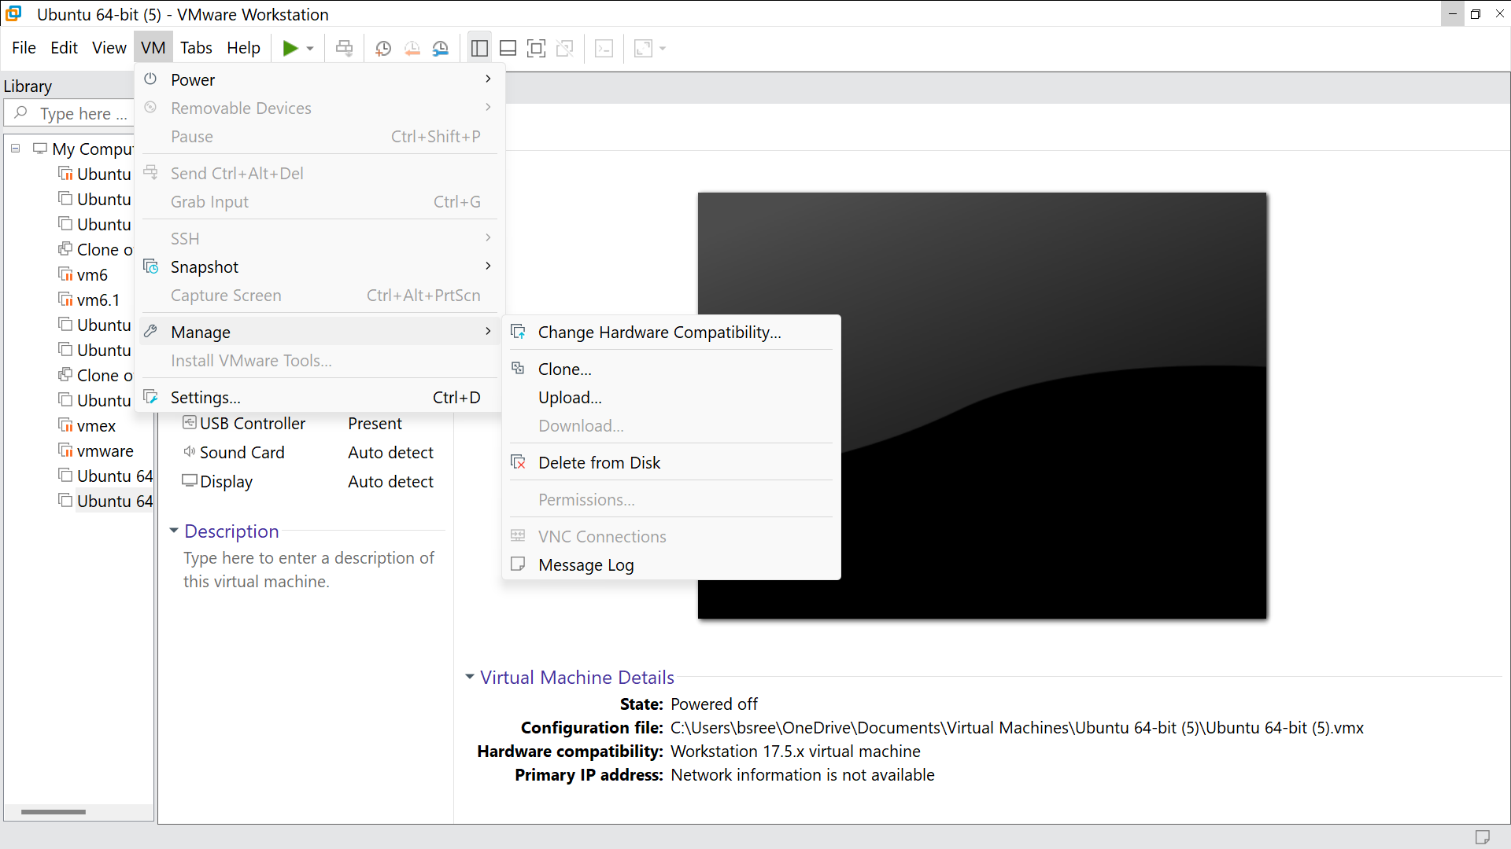

Step 10: GO to clone and Click Next

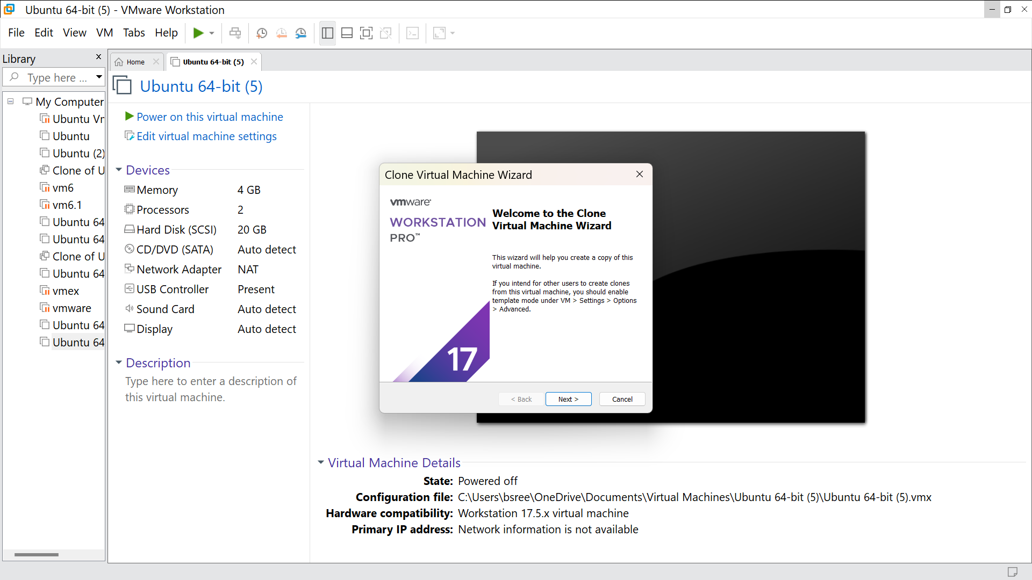

Step 11: Click the option called ‘Current state in the virtual systems and click next

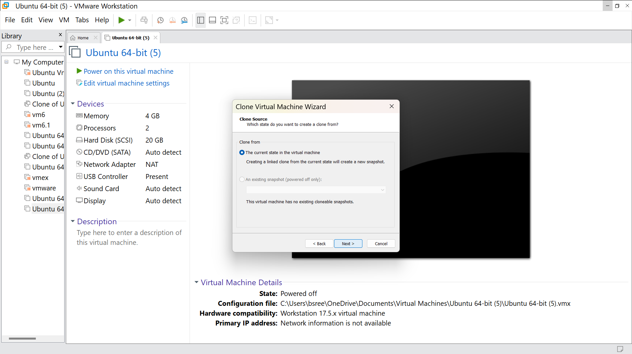

Step 12: Click on ‘Create a linked clone’ and click next

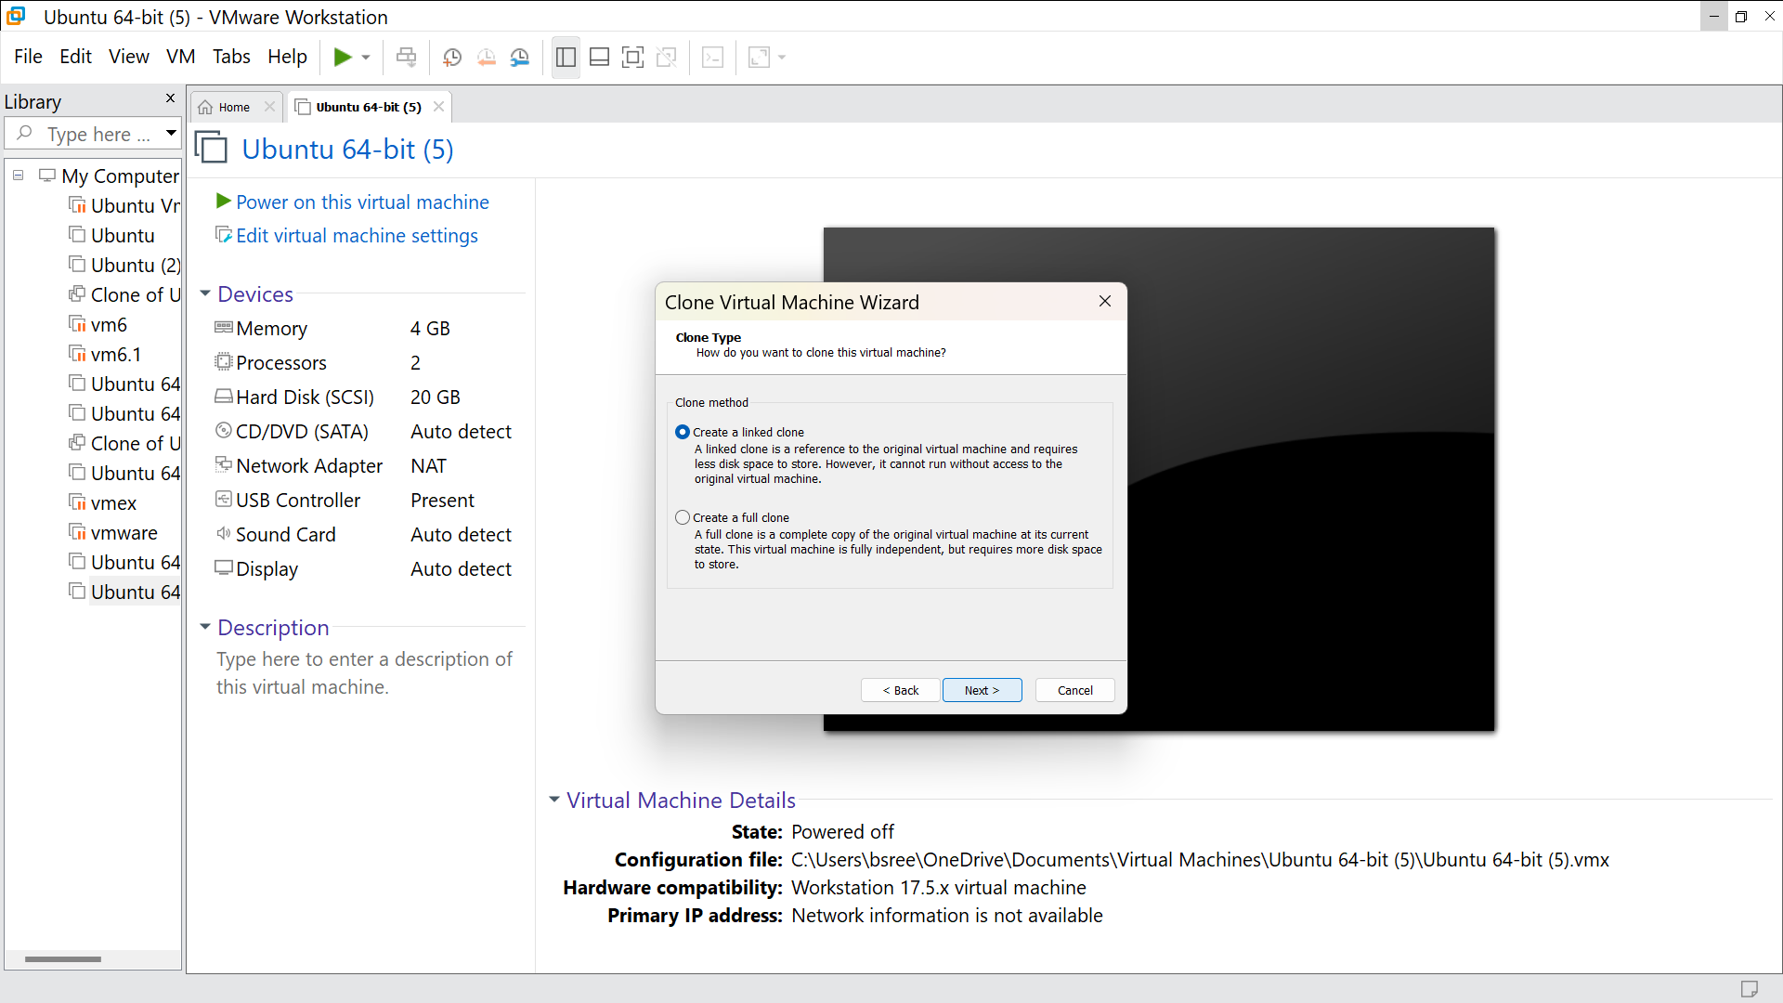

Step 13: Change the virtual machine name and click finish

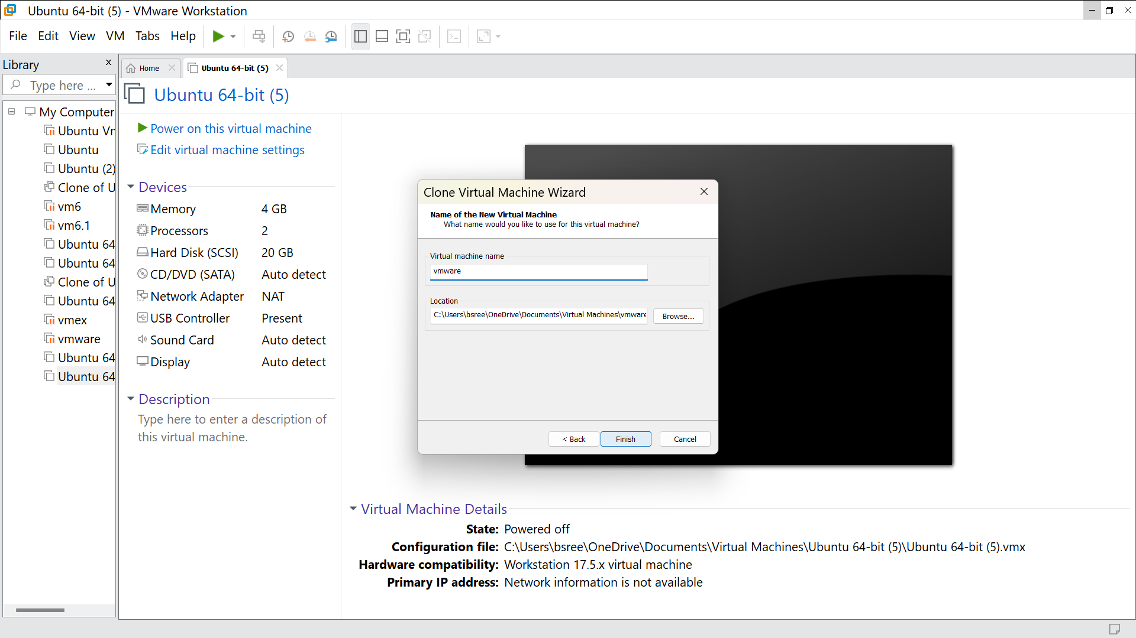

Step 14: Click close

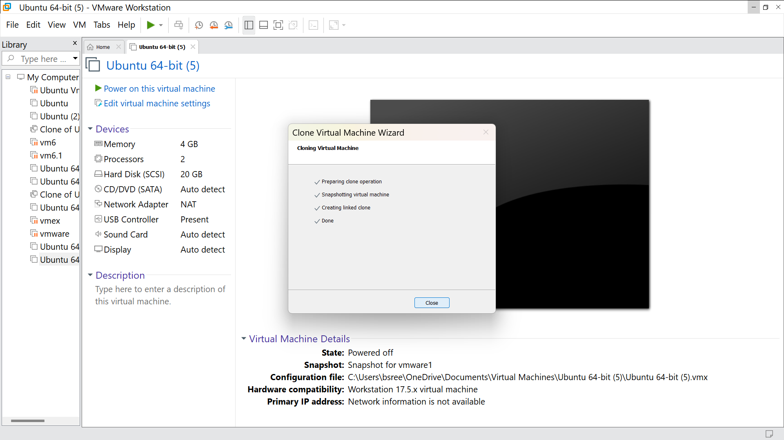

Step 15: It is cloned

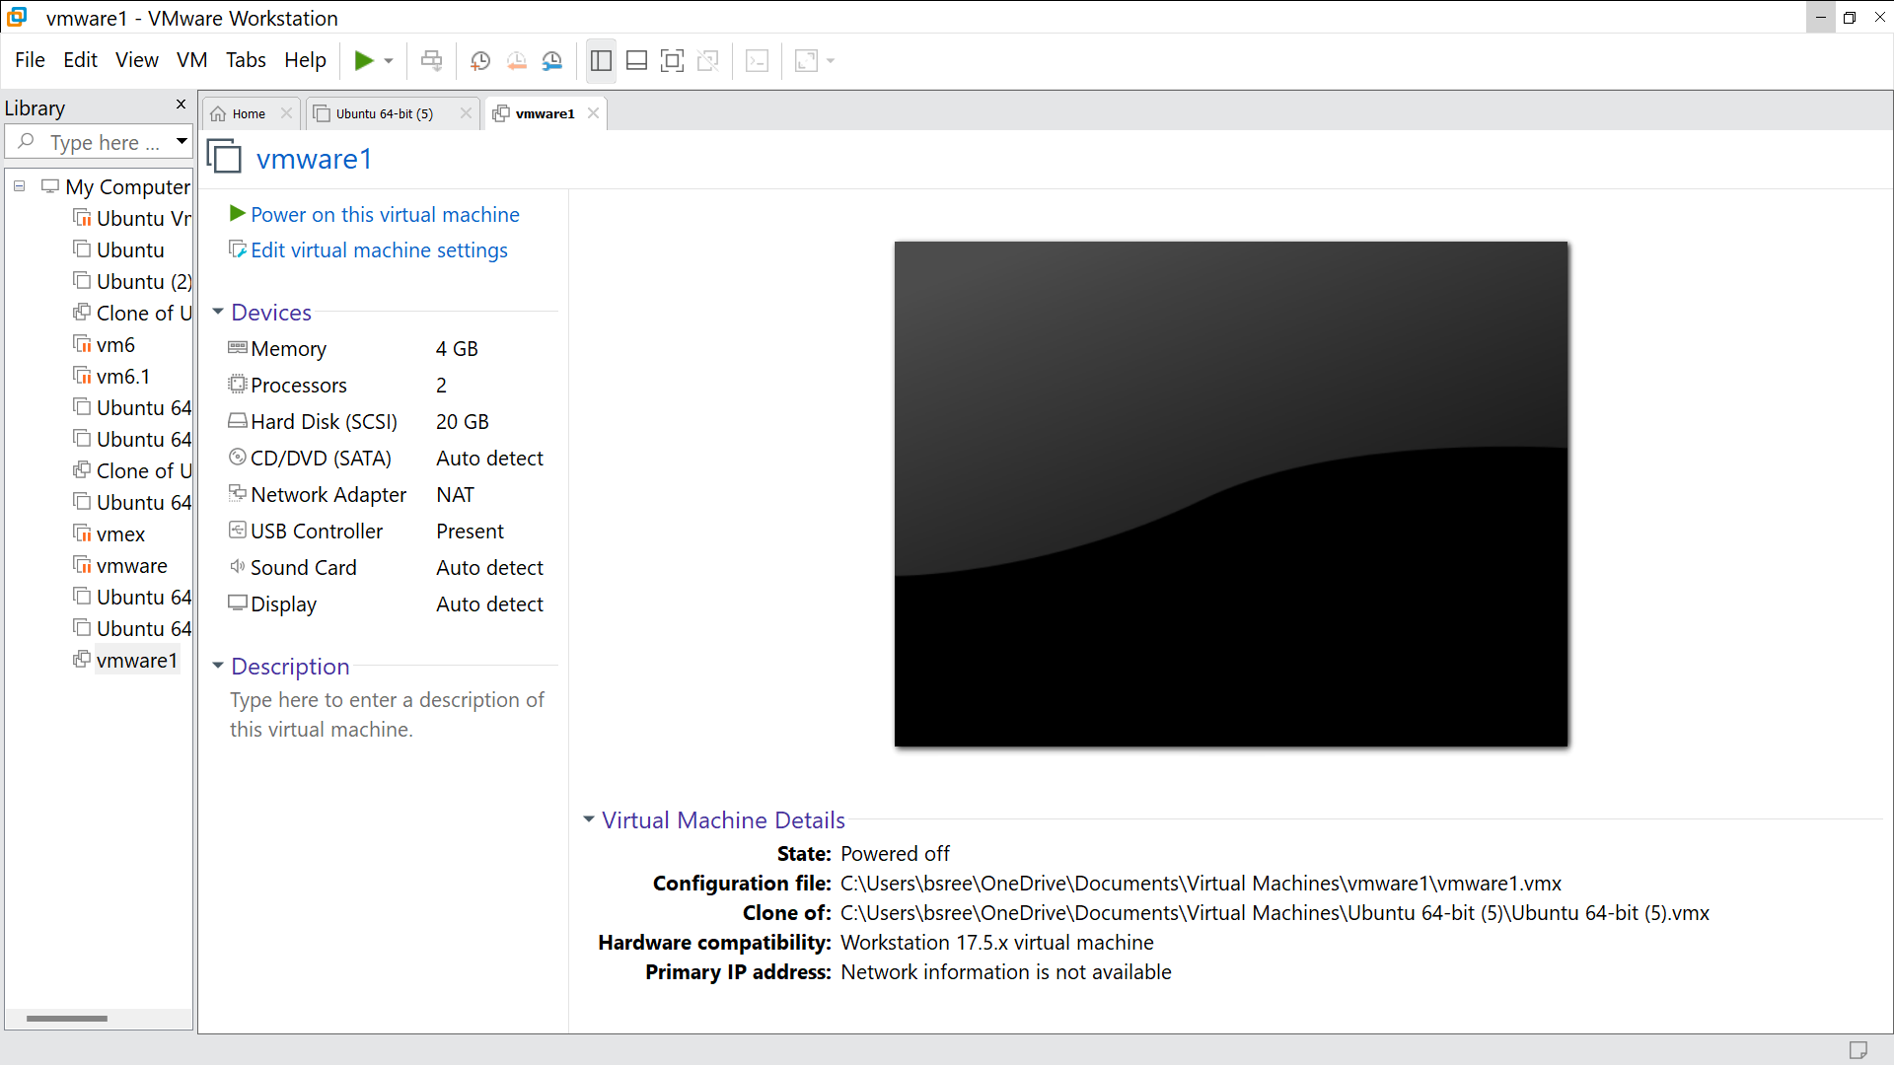

Step 16: Go to VM and go to snapshot, click it

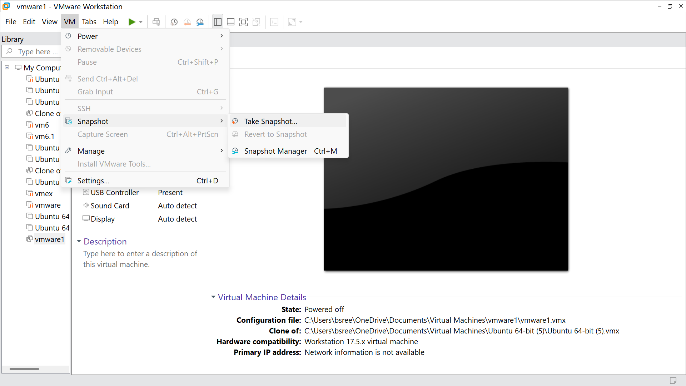

Step 17:Click on take a snapshot

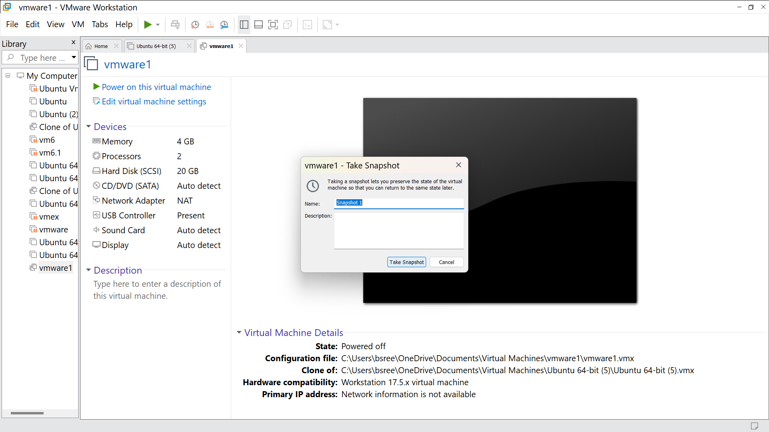

Step 18 : Run it and this will be the output

